Fundamental Theorem of Calculus

$$Suppose the function f at interval$$

$$\left[a,b\right] is continuous and differentiable$$

$$,and\frac{df}{dx} is continuous at \left[a,b\right].$$

$$\int_{a}^{b}{\frac{df}{dx} dx}={f\left(x\right)}_{x=a}^{x=b}=f\left(b\right)-f\left(a\right)$$

$$Prequisite for proof:$$

$$1.Riemmen^{'}s integration.$$

$$2.MVT.$$

$$pf:$$

$$Recall about Reimmen^{'}s integration.$$

$$\left(It is about the definition of integration in Calculus.\right)$$

$$Let^{'}s start at Reimmen^{'}s integration.$$

$$step 1:$$

$$Draw two points a and b at x-axis and split n pieces$$

$$equally at interval \left[a,b\right].$$

$$Illustrated as follows.$$

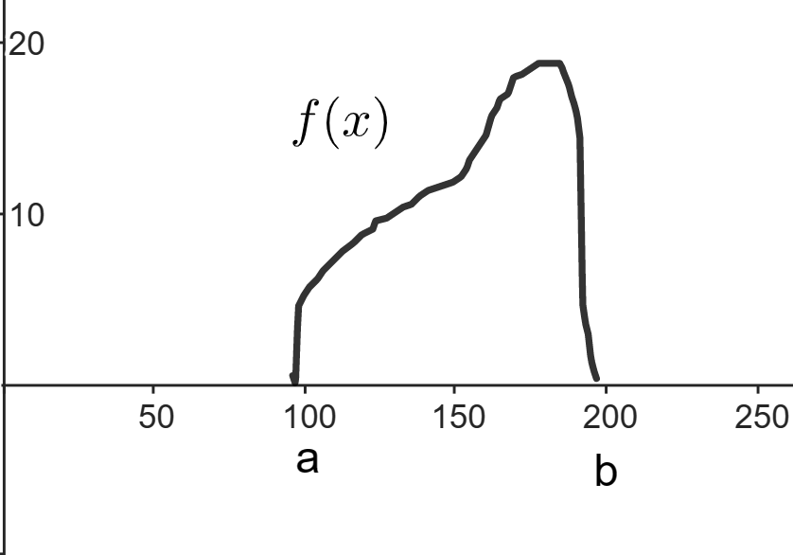

$$step 2:$$

$$Label each points on the bound of pieces.$$

$$w=width of each piece=\frac{b-a}{n}$$

$$Let x_{0}=a,$$

$$x_{1}=x_{0}+w=a+\frac{b-a}{n},$$

$$x_{2}=x_{1}+w=2a+\frac{b-a}{n},$$

$$…,$$

$$x_{k}=x_{k-1}+w=k*a+\frac{b-a}{n},$$

$$…,$$

$$x_{n}=b$$

$$∆x_{k}=x_{k+1}-x_{k}=w$$

$$for all k=1,2,…,n-1$$

$$step 3:$$

$$Evaluate the area of f\left(x\right) at interval \left[a,b\right]$$

$$A_{n}=\sum_{k=0}^{n-1}{f\left(x_{k}\right)*∆x_{k}}$$

$$step 4:$$

$$We observe that if we split infinite piece$$

$$equally,$$

$$then the area is very close to the sum of product of$$

$$width and height of pieces for each peices.$$

$$\int_{a}^{b}{f\left(x\right)dx}=\lim_{n→∞}{A_{n}}=\lim_{n→∞}{\sum_{k=0}^{n-1}{f\left(x_{k}\right)*∆x_{k}}}$$

$$It is Riemenn^{'}s integration.$$

$$Thus,$$

$$\int_{a}^{b}{f^{'}\left(x\right)dx}=\lim_{n→∞}{A_{n}}=\lim_{n→∞}{\sum_{k=0}^{n-1}{f^{'}\left(x_{k}\right)*∆x_{k}}}$$

$$By MVT \left(Mean Value Theorem\right),$$

$$\frac{f\left(x_{k+1}\right)-f\left(x_{k}\right)}{\left(x_{k+1}-x_{k}\right)}=f^{'}\left(x_{i}\right)$$

$$=>f\left(x_{k+1}\right)-f\left(x_{k}\right)=\left(x_{k+1}-x_{k}\right)*f^{'}\left(x_{i}\right)=∆x_{i}*f^{'}\left(x_{i}\right)$$

$$Thus,$$

$$\int_{a}^{b}{f^{'}\left(x\right)dx}$$

$$=\lim_{n→∞}{\sum_{k=0}^{n-1}{\left[f\left(x_{k+1}\right)-f\left(x_{k}\right)\right]}}$$

$$=\lim_{n→∞}{f\left(x_{1}\right)-f\left(x_{0}\right)+f\left(x_{2}\right)-f\left(x_{1}\right)+f\left(x_{3}\right)-f\left(x_{2}\right)+…+f\left(x_{n}\right)-f\left(x_{n-1}\right)}$$

$$=f\left(x_{n-1}\right)-f\left(x_{0}\right)$$

$$=f\left(b\right)-f(a)$$

Ref:

[Proof of the Fundamental Theorem of Calculus - YouTube](https://www.youtube.com/watch?v=vf5f_SuZ6XE)